Tech Nation Visa — Global Talent (Exceptional Promise)
Criteria: Mandatory Criteria — Sustained Technical Leadership
Applicant: Odeyemi Olusegun Israel

MC-2: Verifiable Sole Authorship and Sustained Engineering Record
1. Claim

The AMTTP repository proves sustained, self-directed authorship across blockchain, AI, backend, frontend, SDK, security, and research tooling. This is not a single prototype; it is a full-stack engineering record spanning September 2025 to April 2026.
Claim | Evidence | Independent verification
Sustained development | 361 commits over eight months | github.com/segetii/AMTTP commit history
Sole-authored breadth | Python, TypeScript, Dart, Solidity | repo tree + per-file diffs
ML work gap explained | Nov/Dec Colab artefacts | Google Drive timestamped export folders
Delivery not theory | contracts, services, frontends, SDKs | monorepo folders and deployments

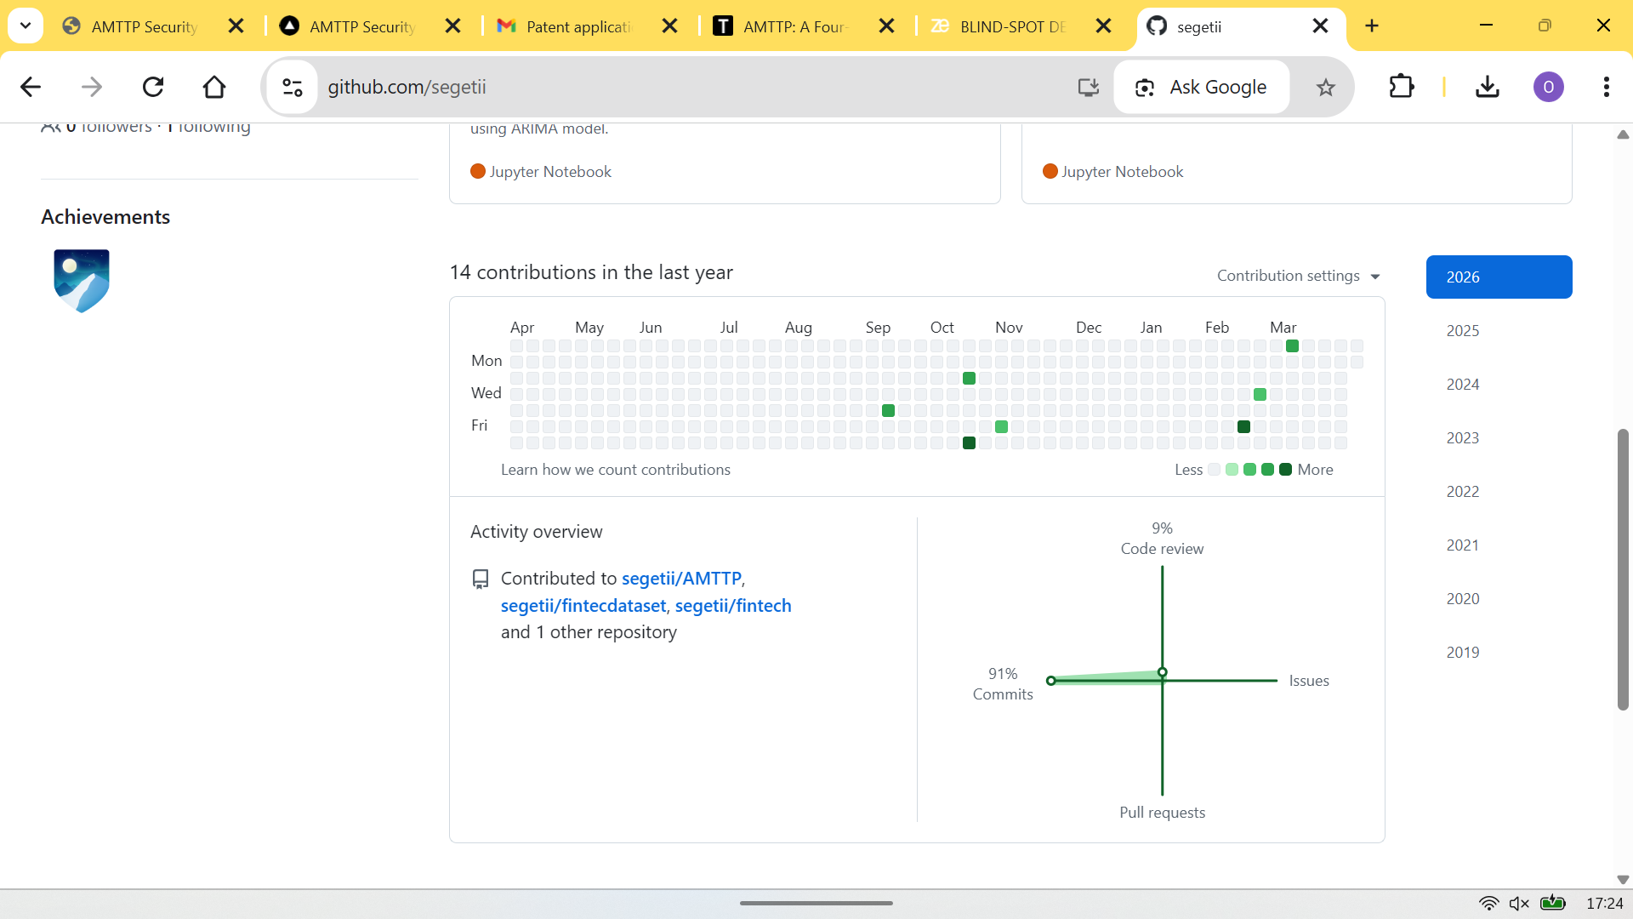
Figure 1: GitHub activity graph — sustained public development cadence.
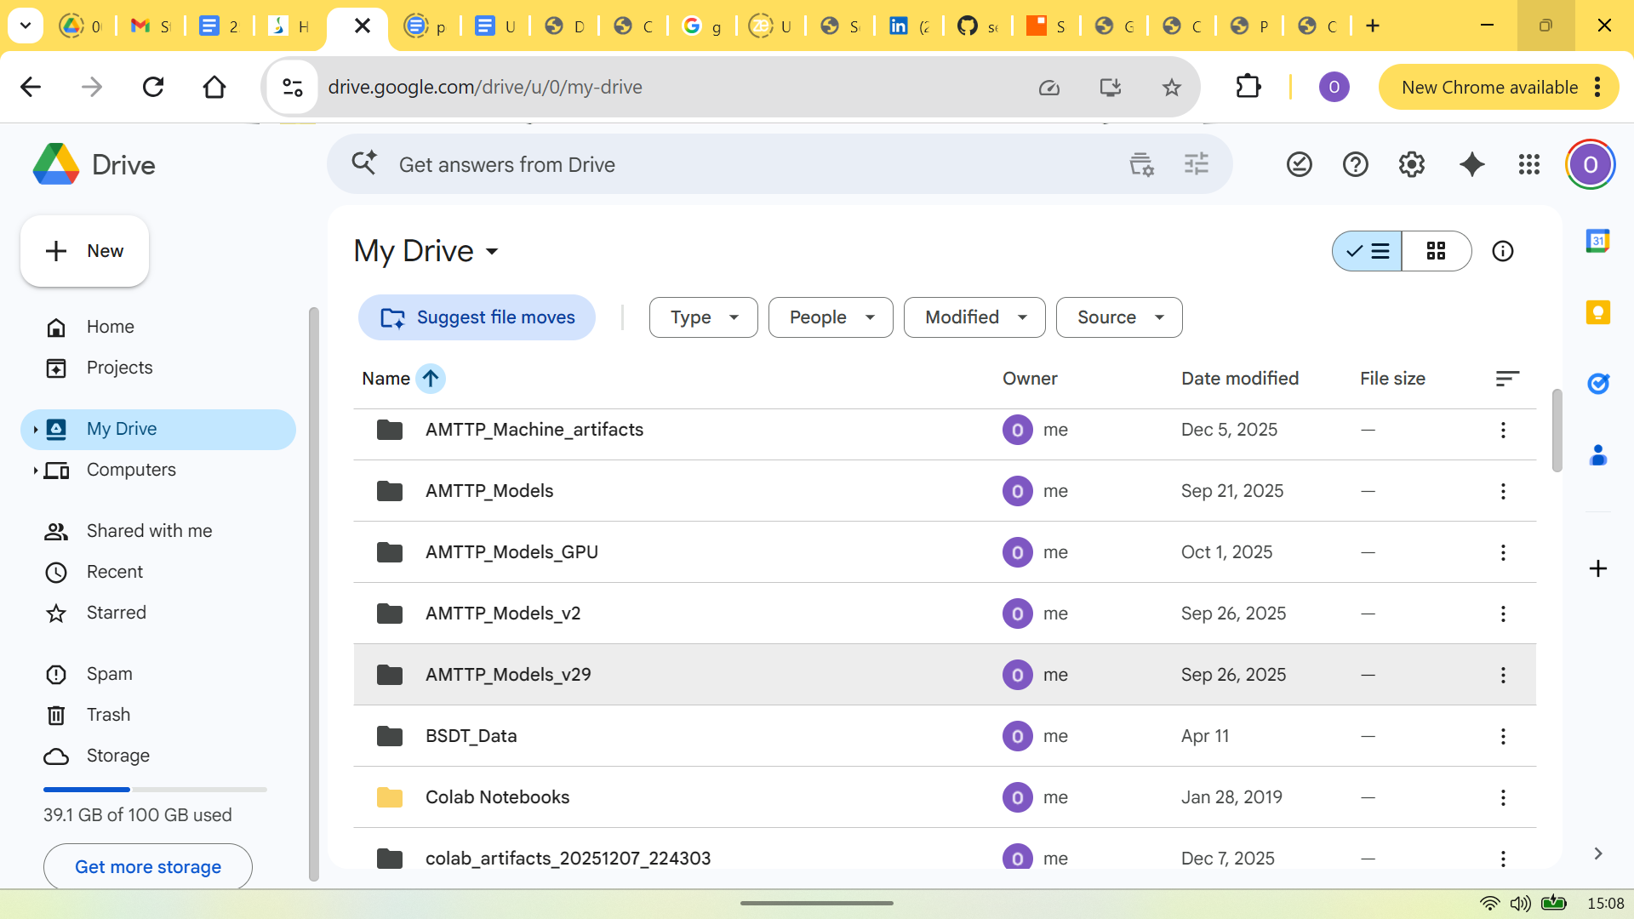
Figure 2: Google-timestamped Colab artefacts corroborating ML work outside GitHub during Nov-Dec 2025.
Domain | Deliverable | Verification
AI/ML | risk engine + benchmarks | ml/Automation/
Blockchain | 38 Solidity contracts | contracts/ + Sepolia
Backend | gateway + microservices | backend/
Frontend | Next.js + Flutter | frontend/
Distribution | TS + Python SDKs | packages/

Anti-loophole note: The claim is independently inspectable: repository timestamps, file history, folder structure, and Colab timestamps provide a verification chain.

